**Computer Graphics**

**Final Project – 2.5D Navigator**

The goal of the project is to render a 3D model of Woodward hall, as per the given floor diagram and implement a Navigation system.

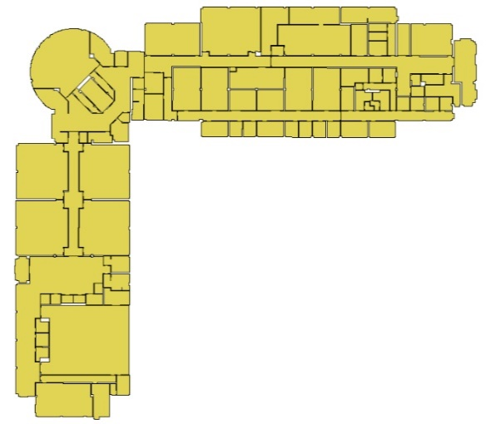

**Output**

Below are the screen shots of my final render of the Woodward hall.

**Outside view**

The complete 3D model as per the floor plan is modeled (using Blender) and rendered.

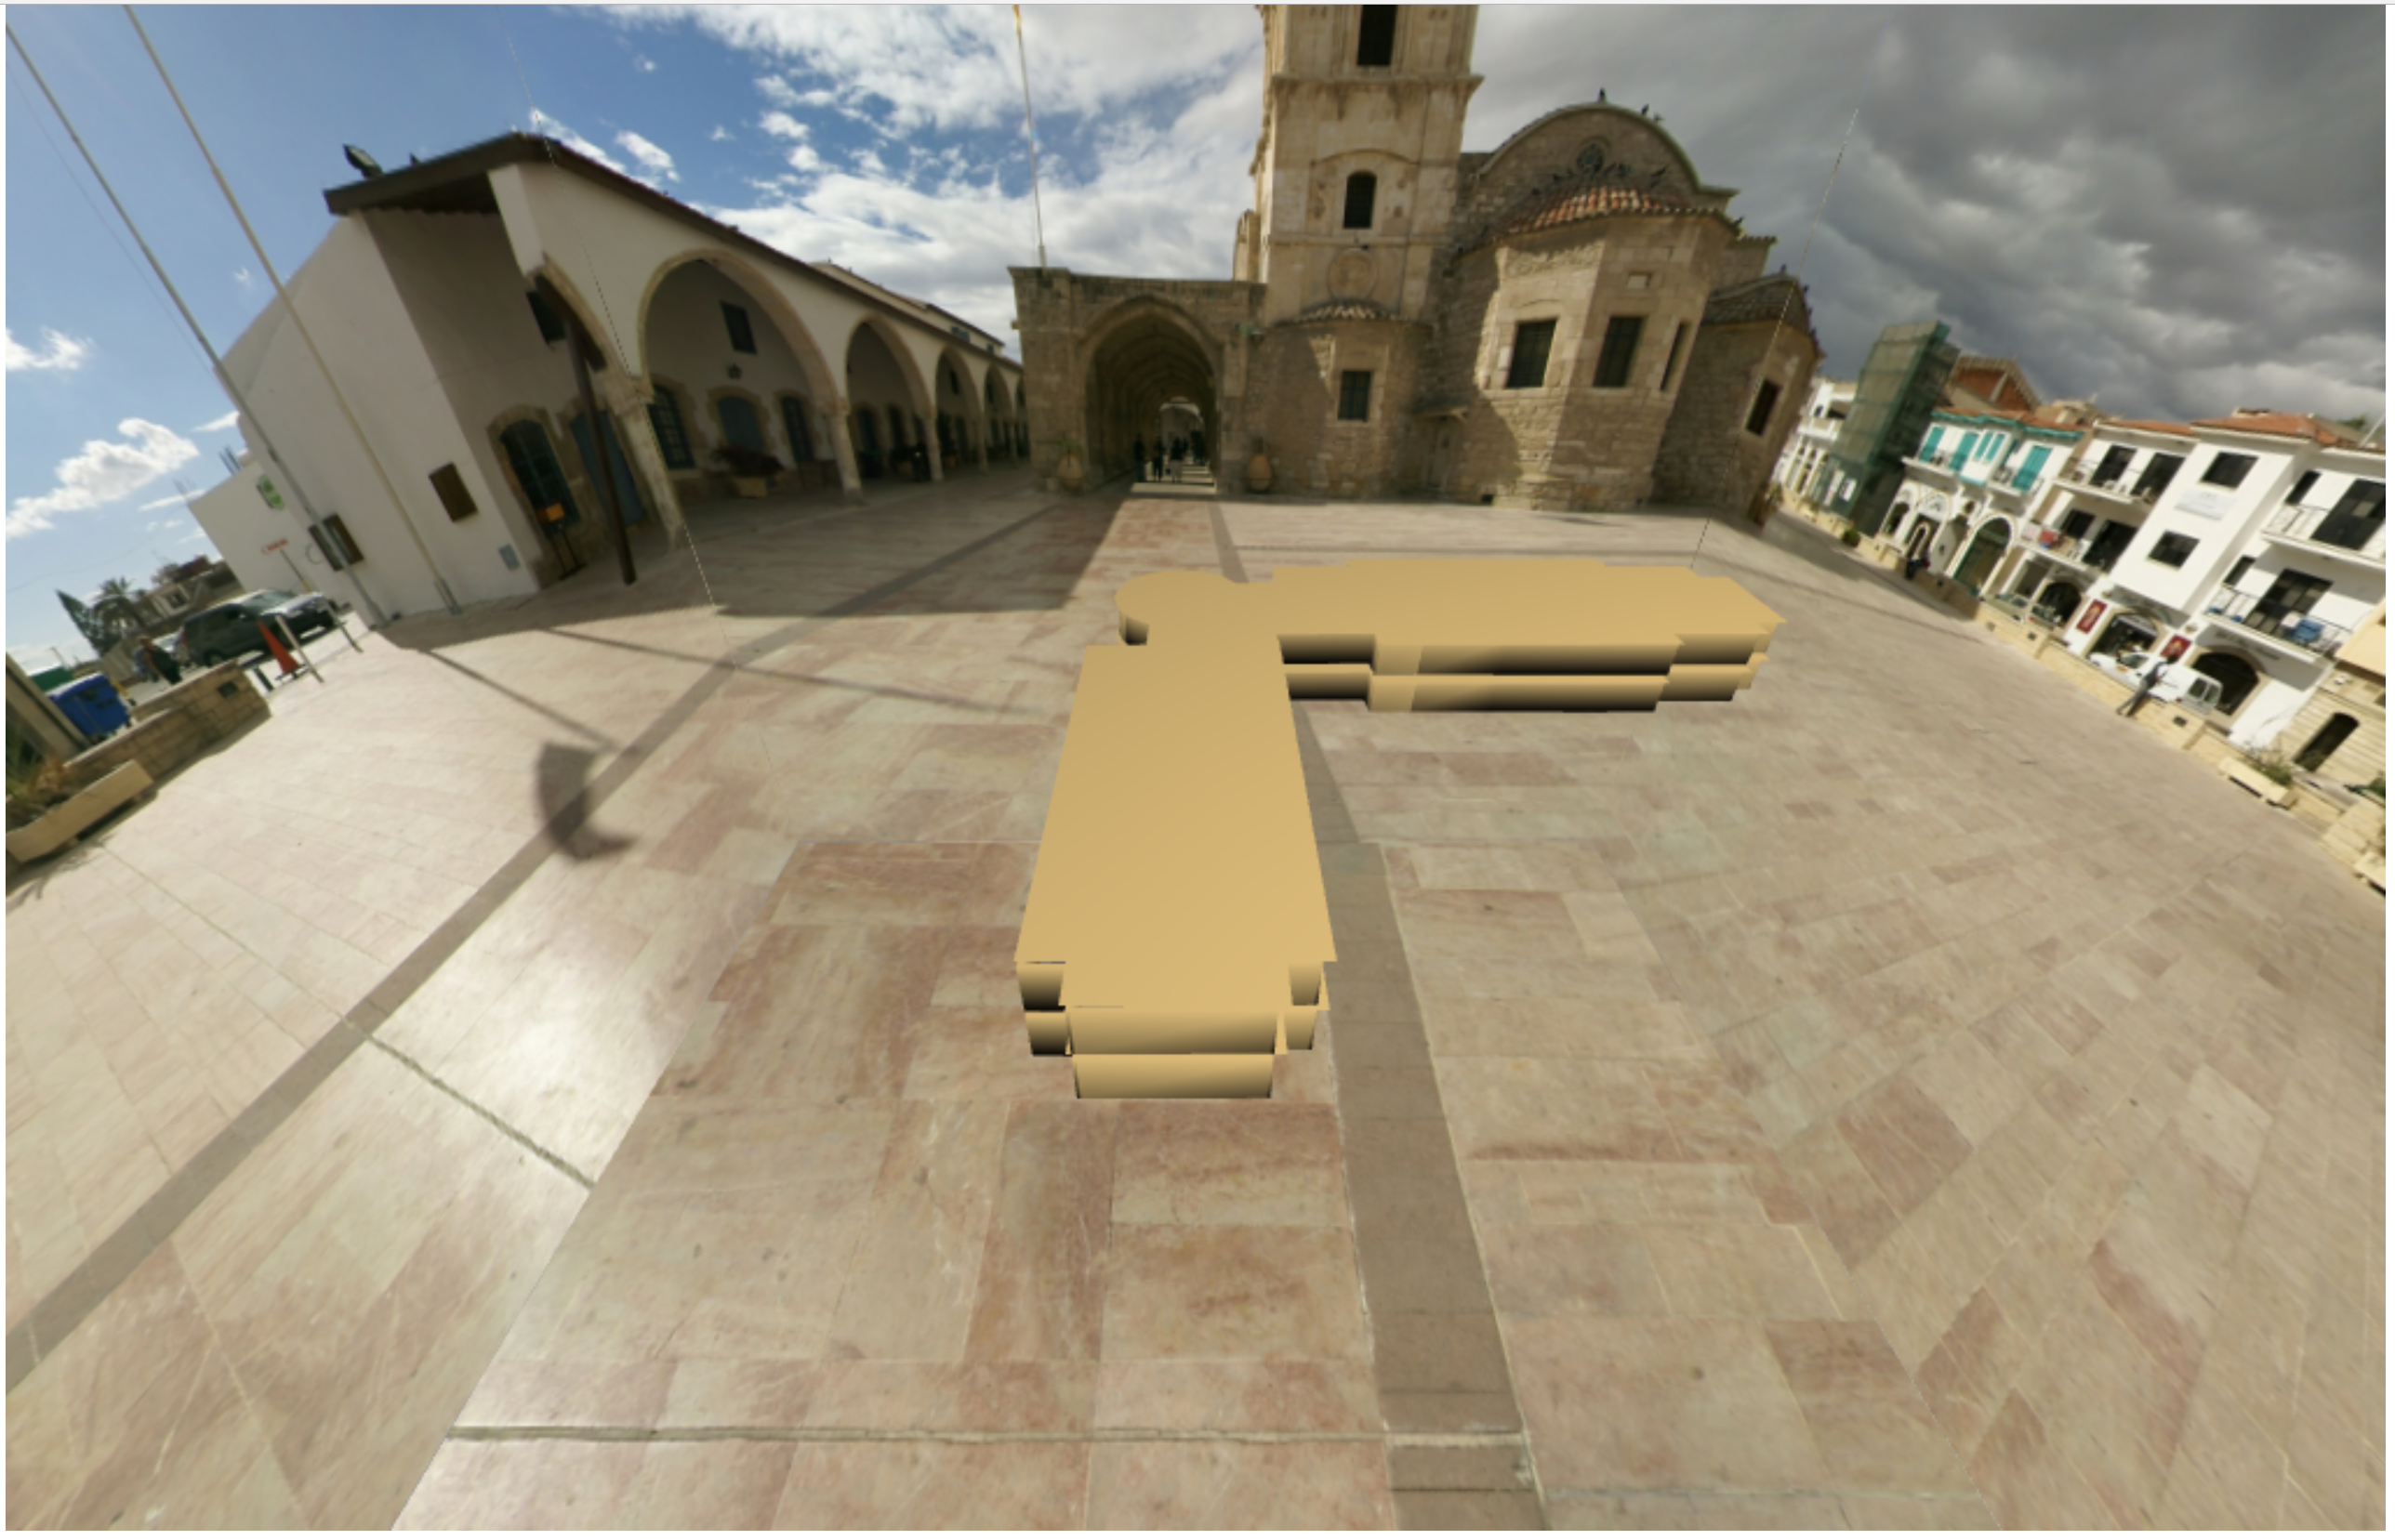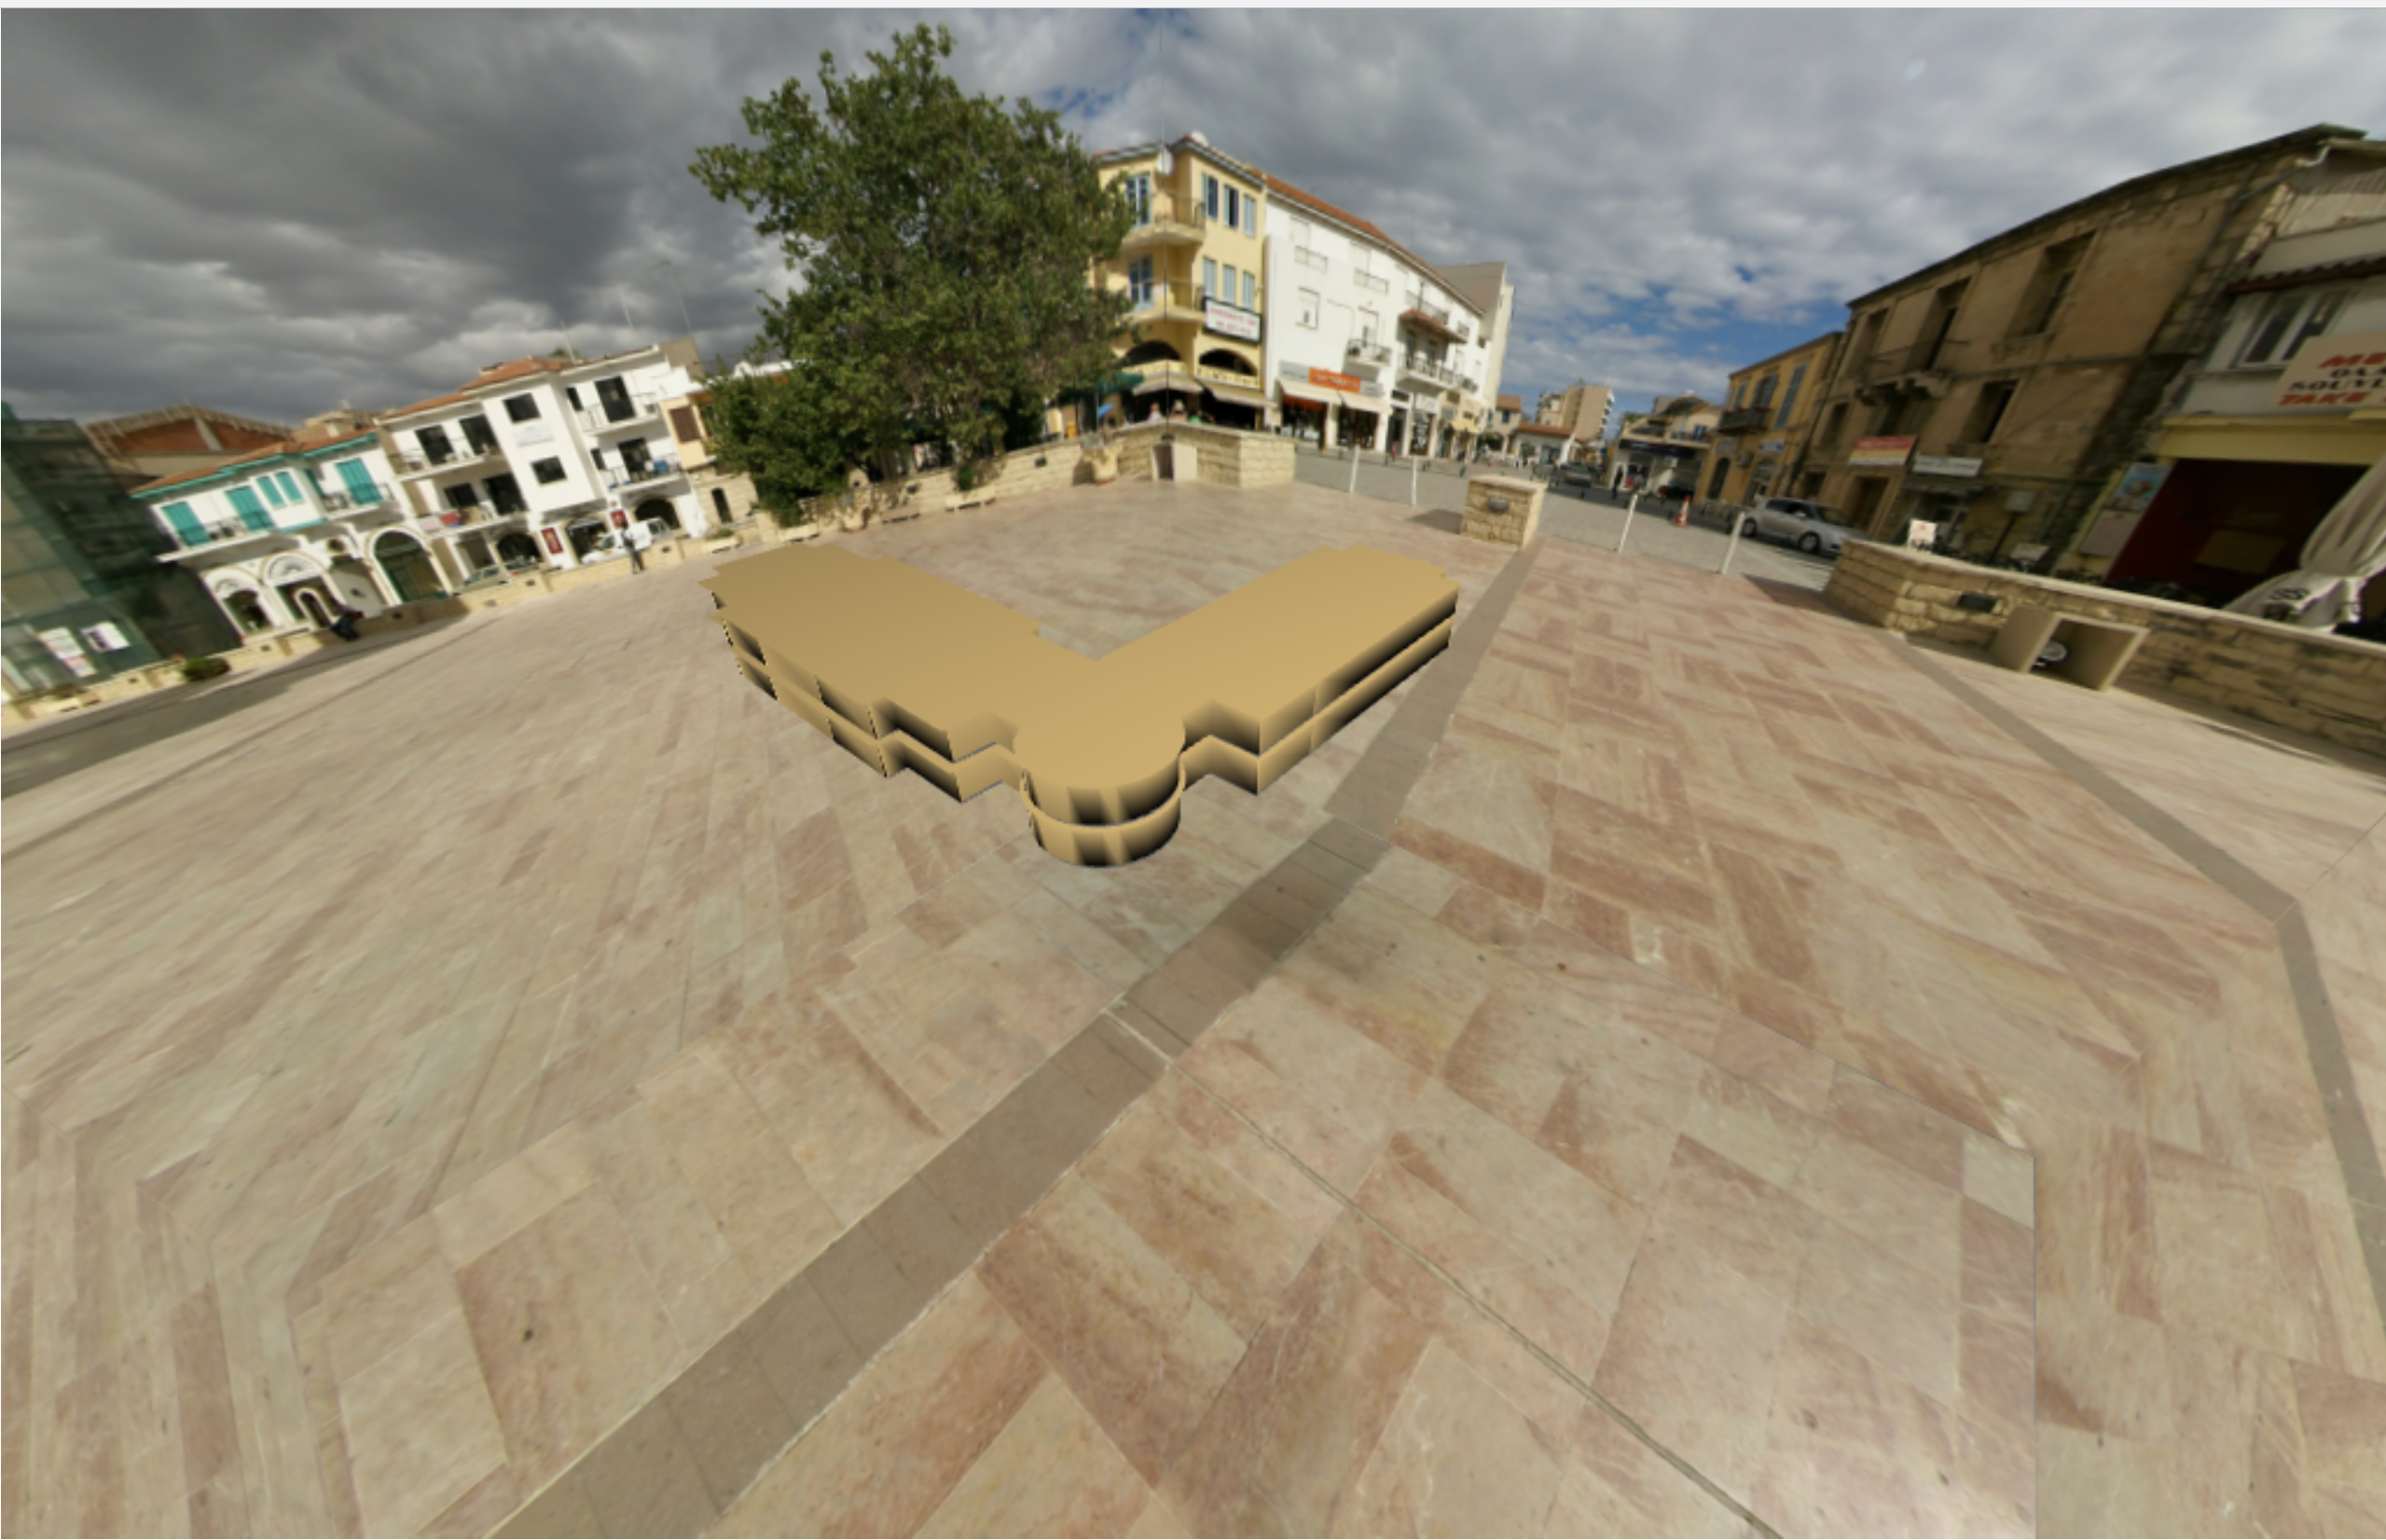

**Inside View**

The floor and walls are accurately colored and lot of texture maps are applied to render objects like vending machine, couch, door, elevator, white boards, notice boards, University logo and Mr. Woodward’s statue.

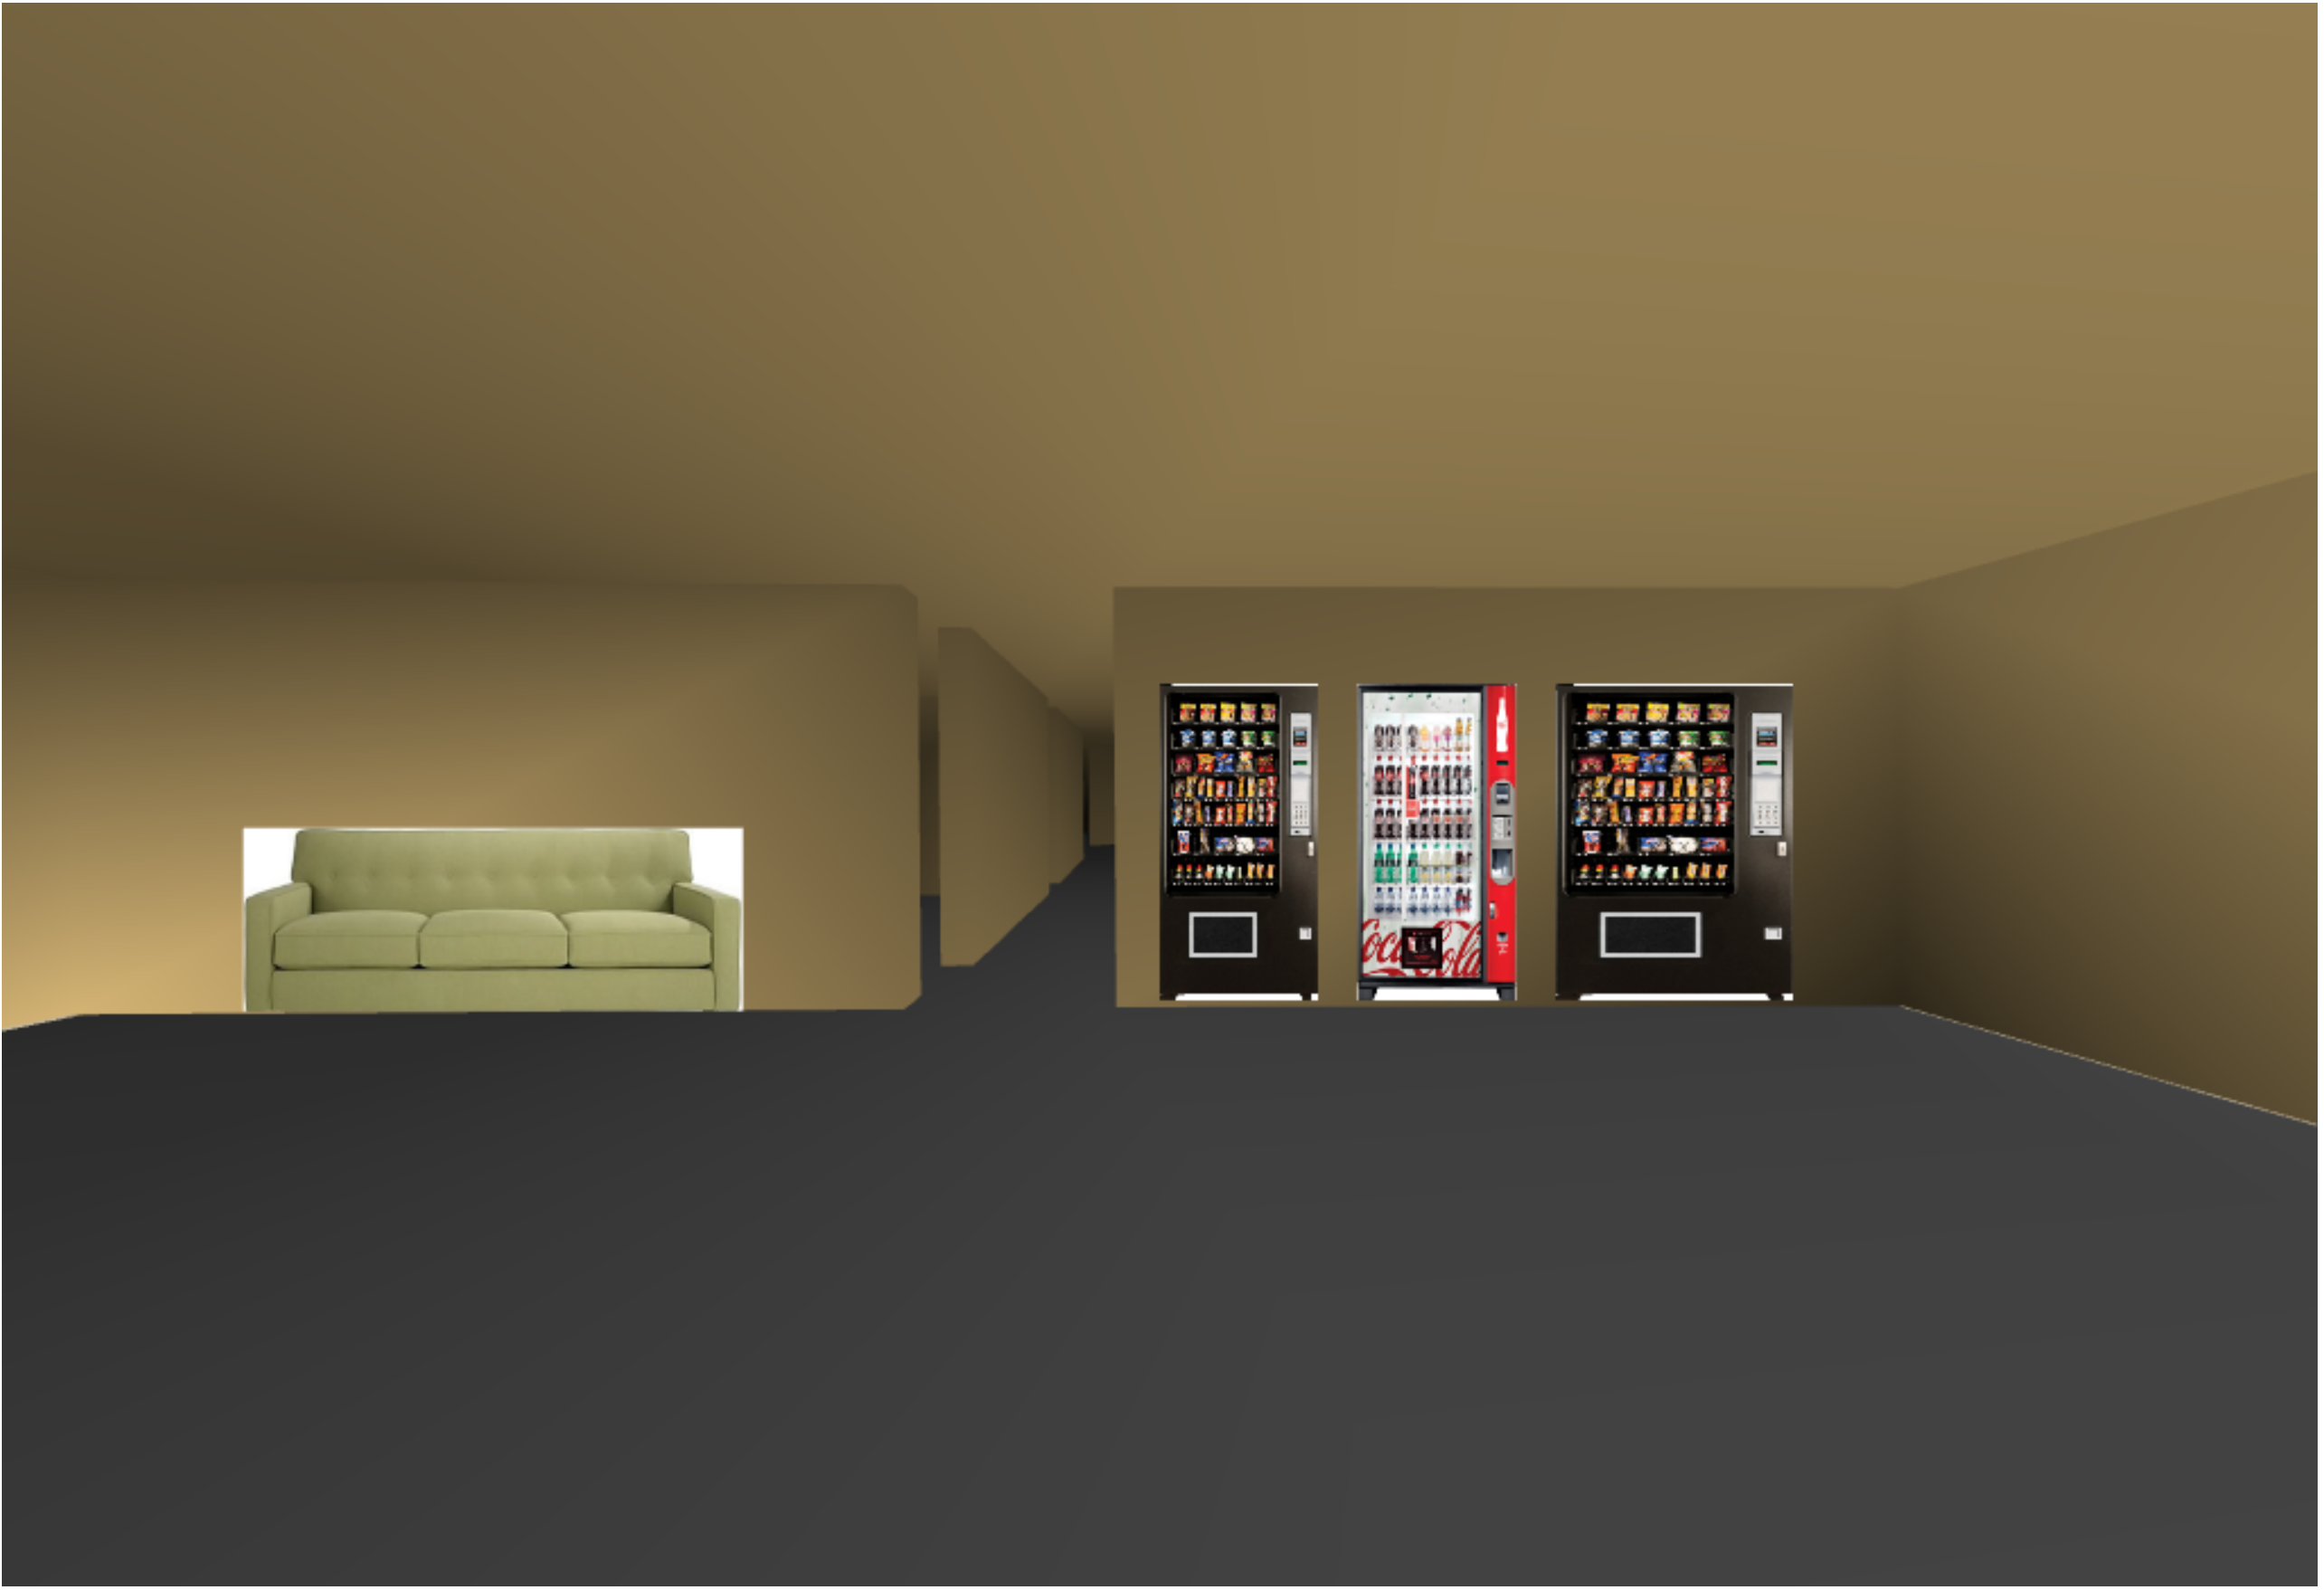 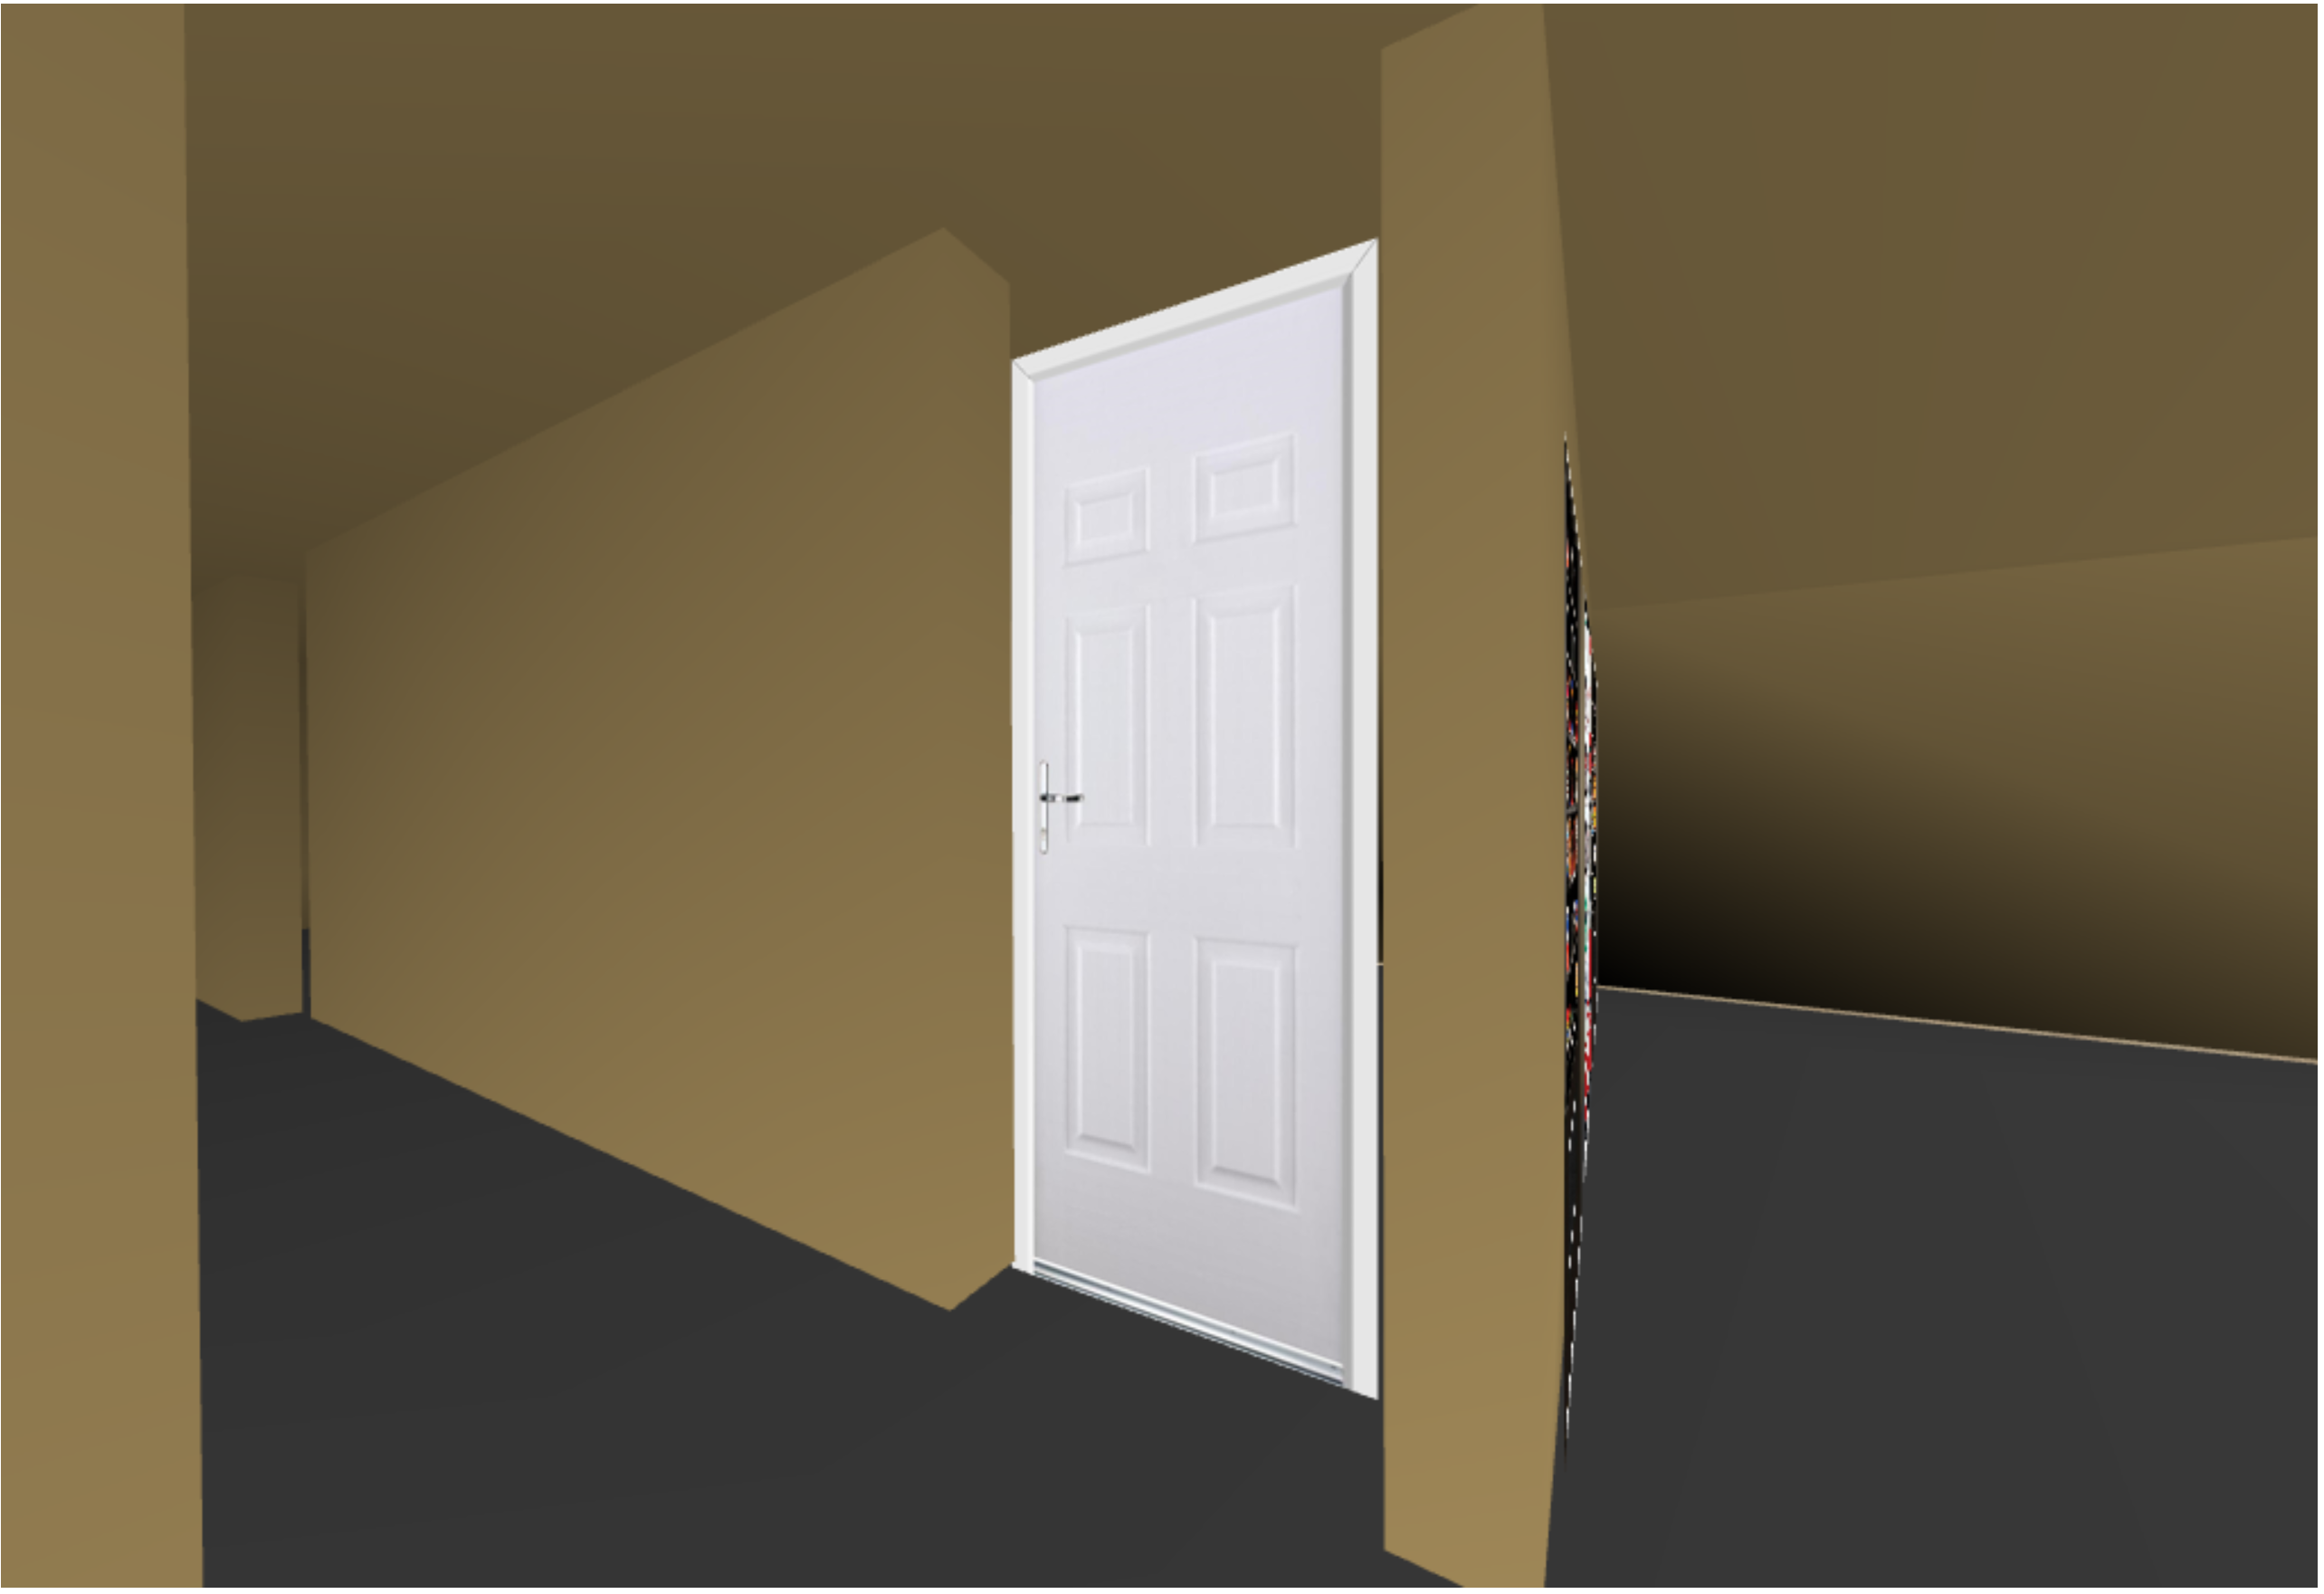

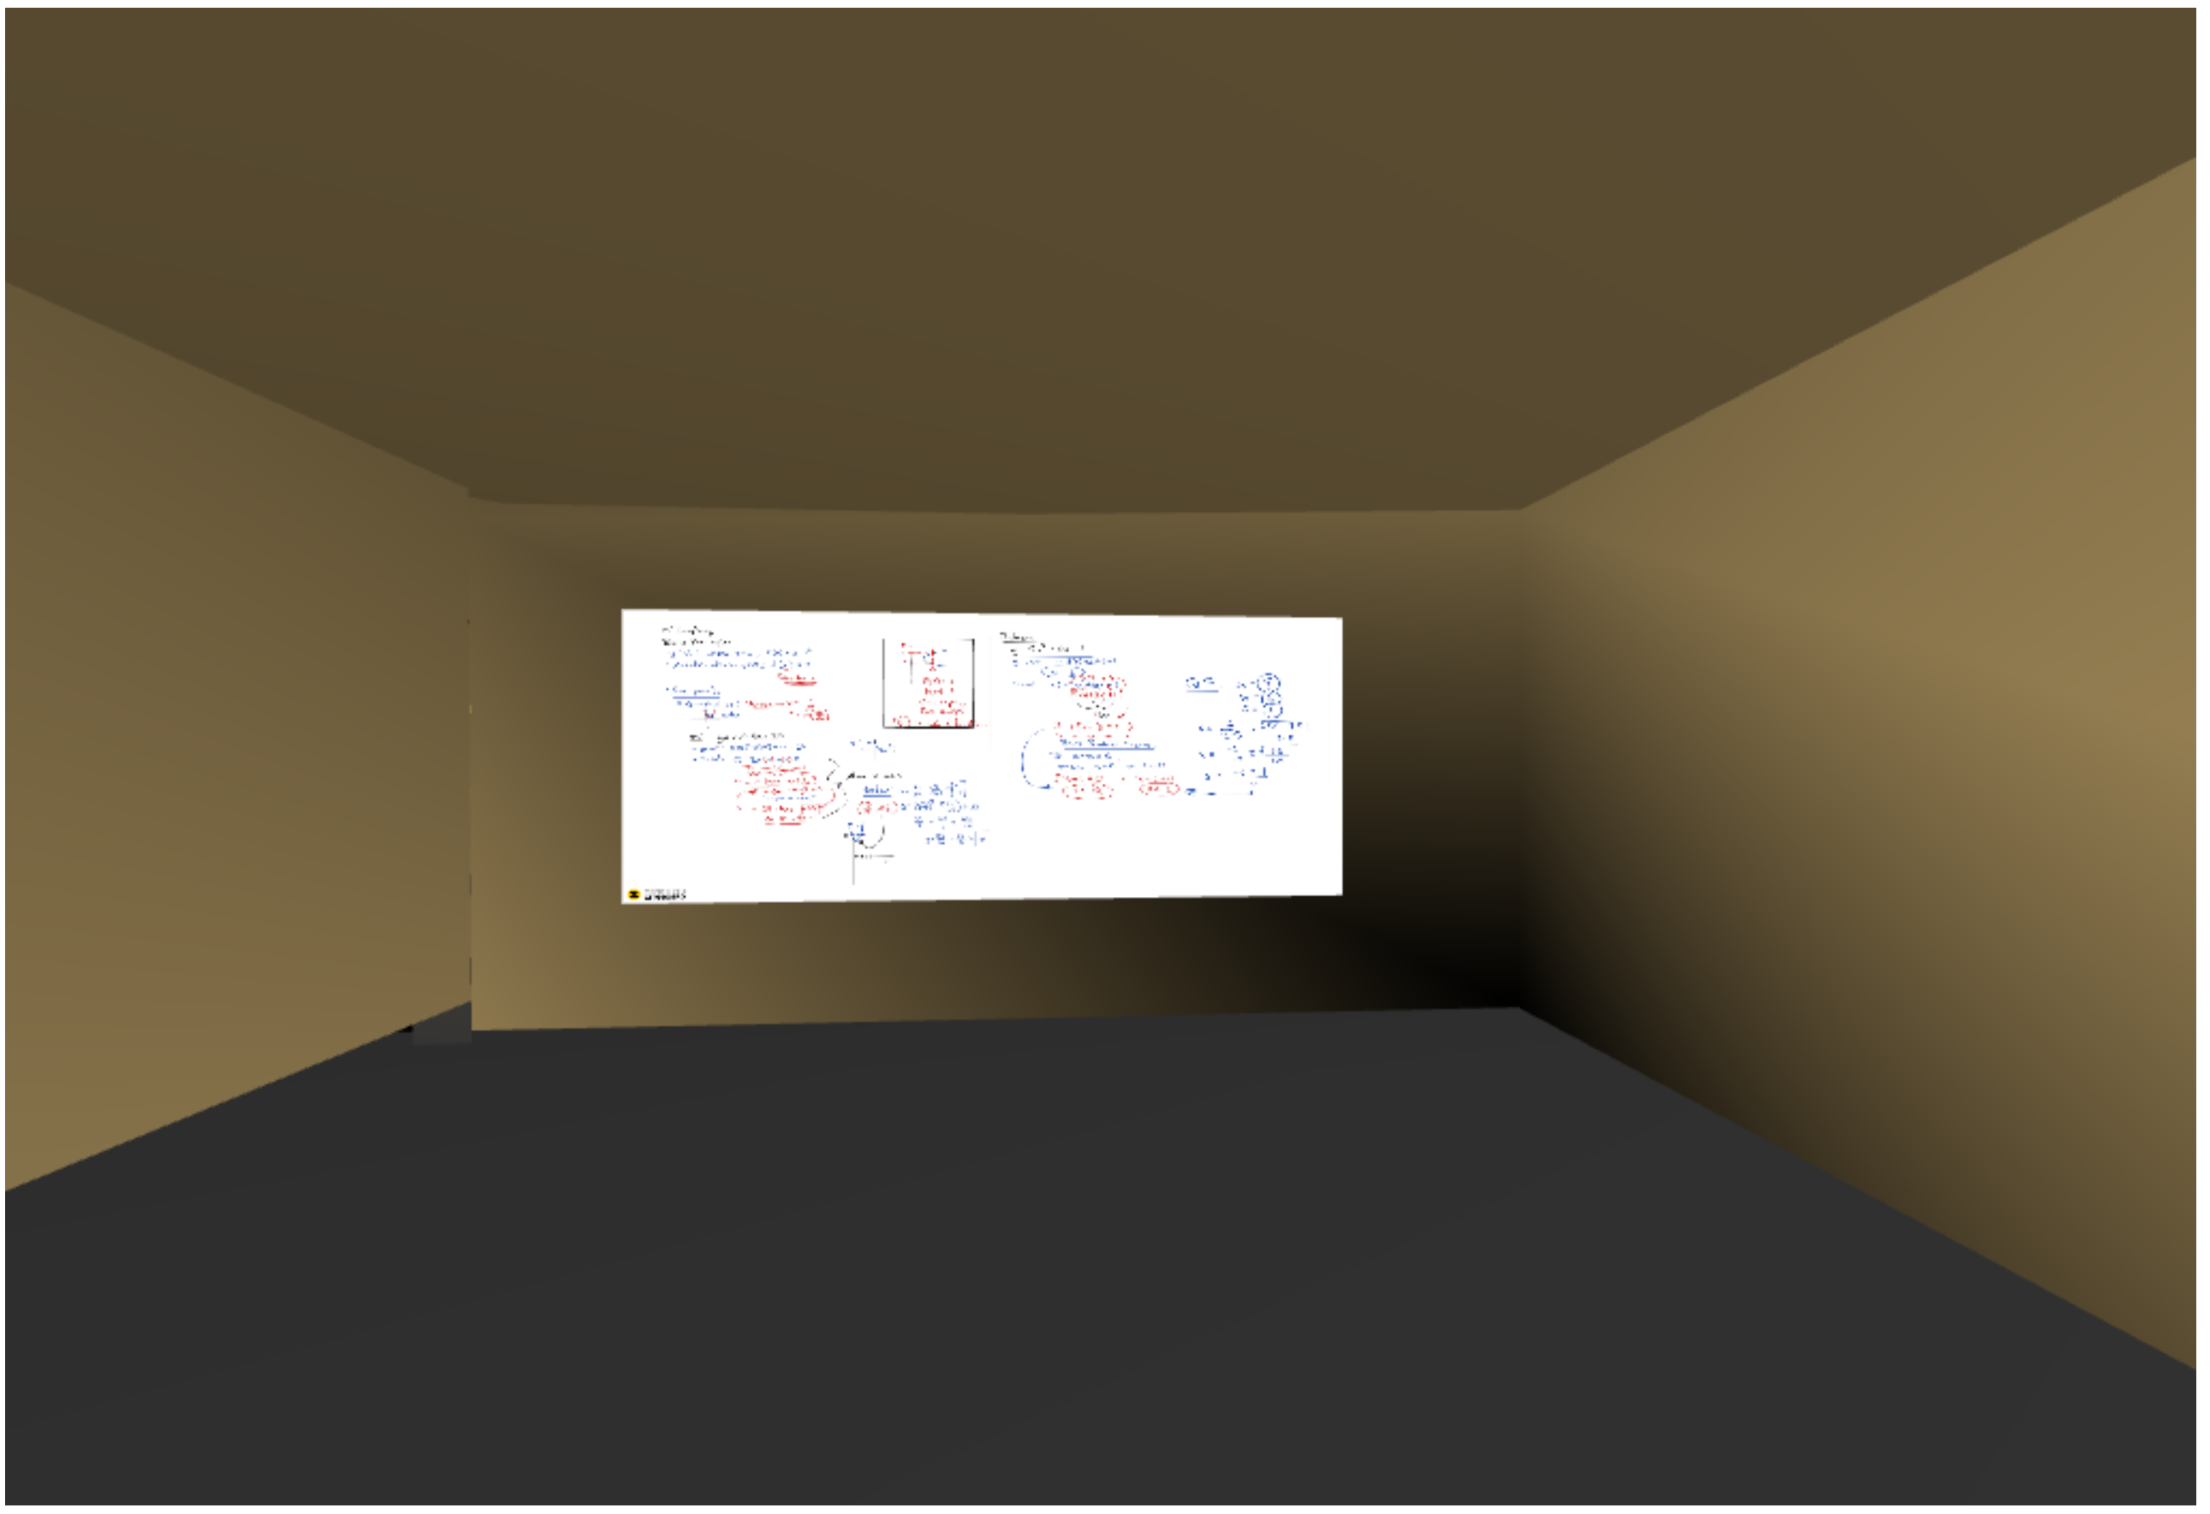 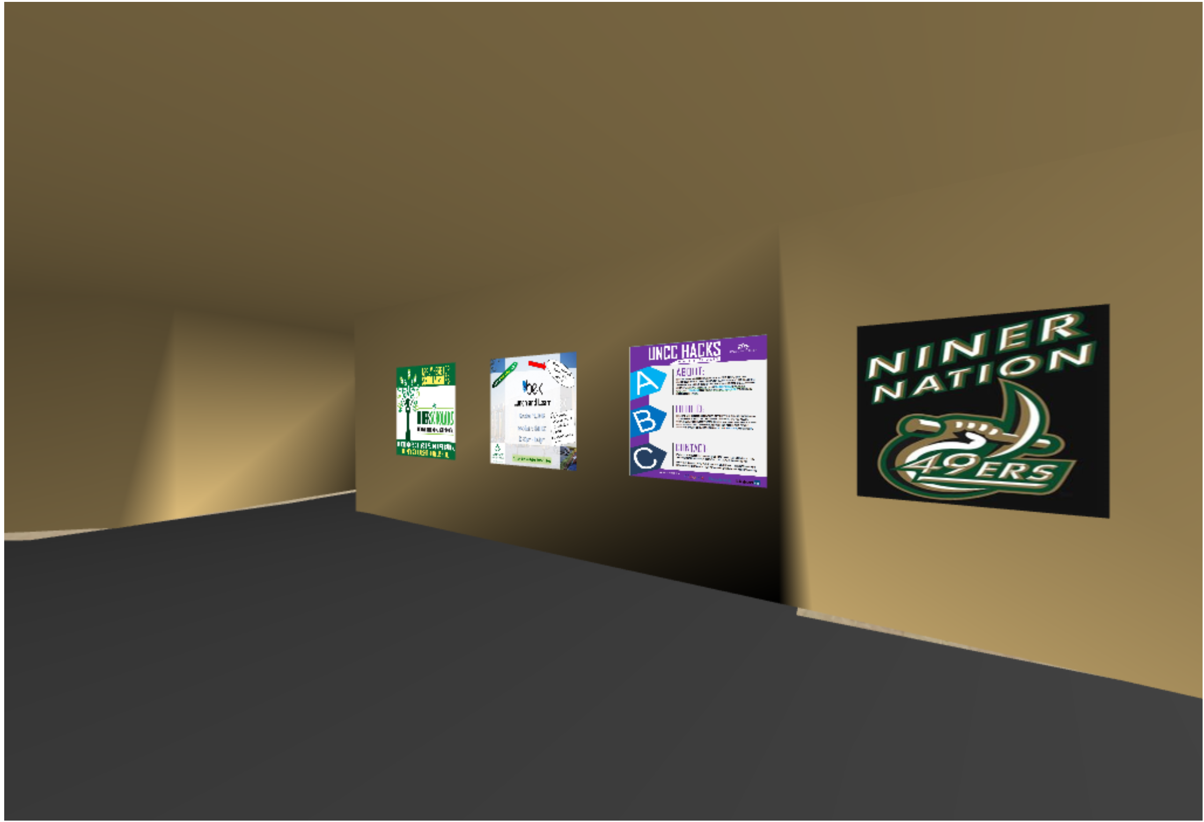

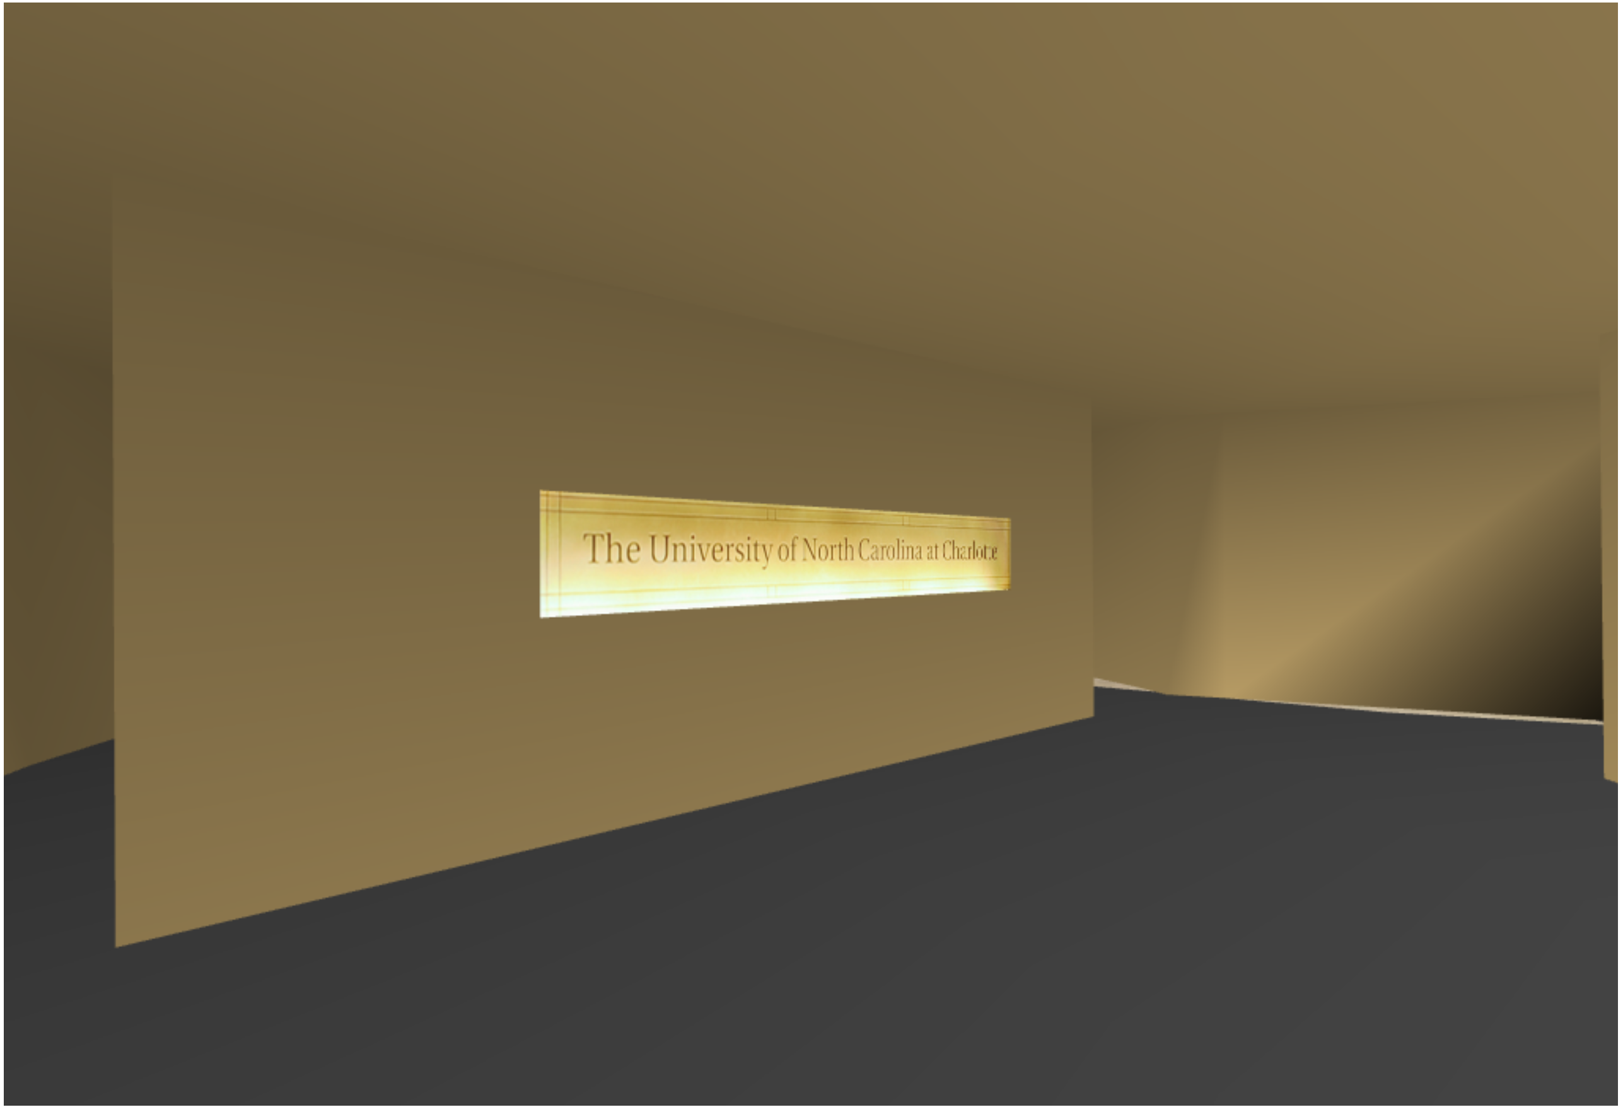 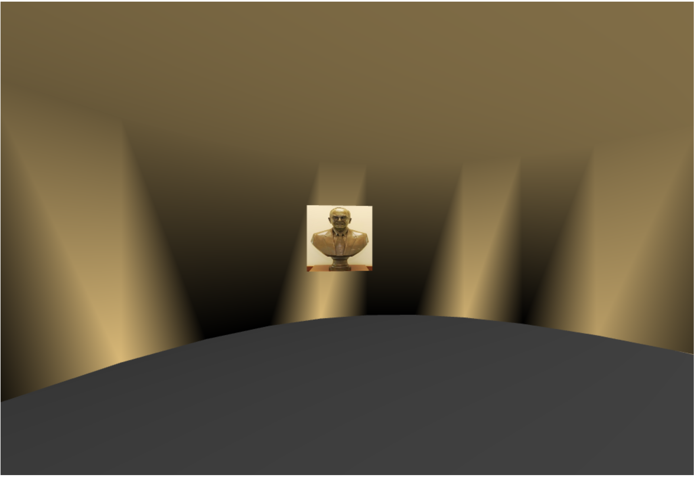

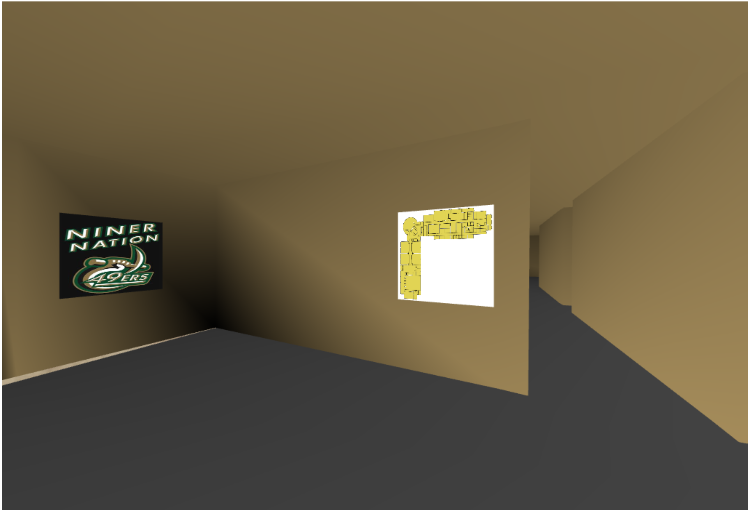 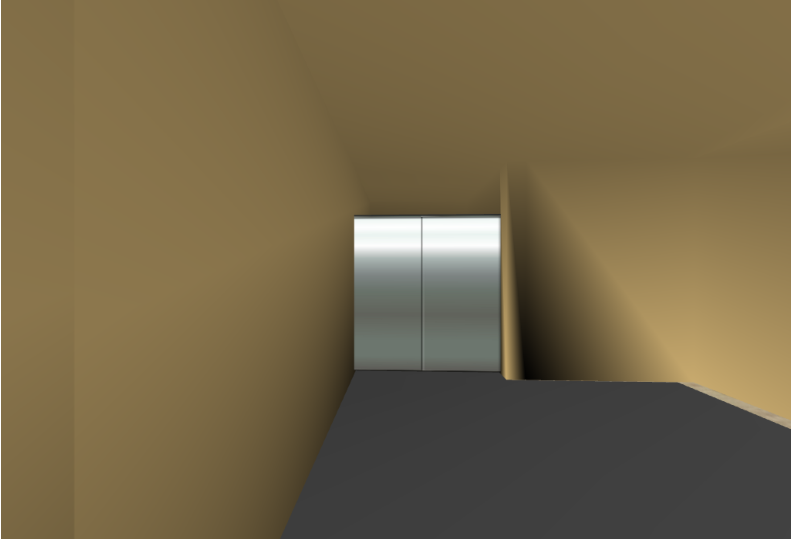

**User Interaction**

**Mouse interaction**

A check box is implemented to toggle between free-walk and top of the view the building. Free-walk enables the user to walk inside the building and explore each corner of the building. When in top view mode user can switch between different views of building by using “Toggle View” button. Also, a Camera Reset button is provided for convenience, which reset the user to initial position.

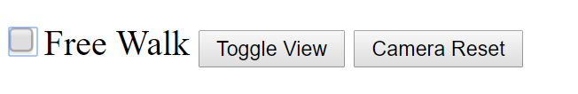

**Keyboard interaction.**

**Walk**

User could walk and explore building by using standard ‘w’, ’s’, ‘a’, ‘d’ key.

‘w’ – walk forward.

‘s’ – walk backward.

‘a’ – strafe left.

‘d’ – strafe right.

left arrow – turn left.

right arrow – turn right.

**Door**

A door could be interactively opened and closed.

‘v’ – open door.

‘b’ – close door.

 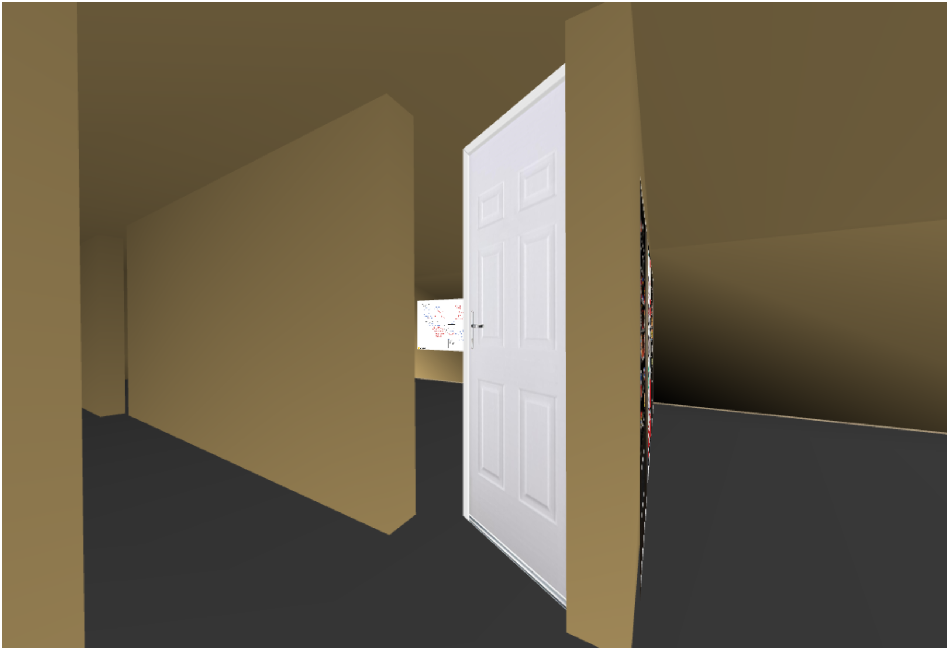

**Elevator**

Elevator door could be interactively opened and closed.

‘e’ – open elevator door.

‘r’ – close elevator door.

‘t’ – move to above/ below floor.

The top floor is given different color for visual difference.

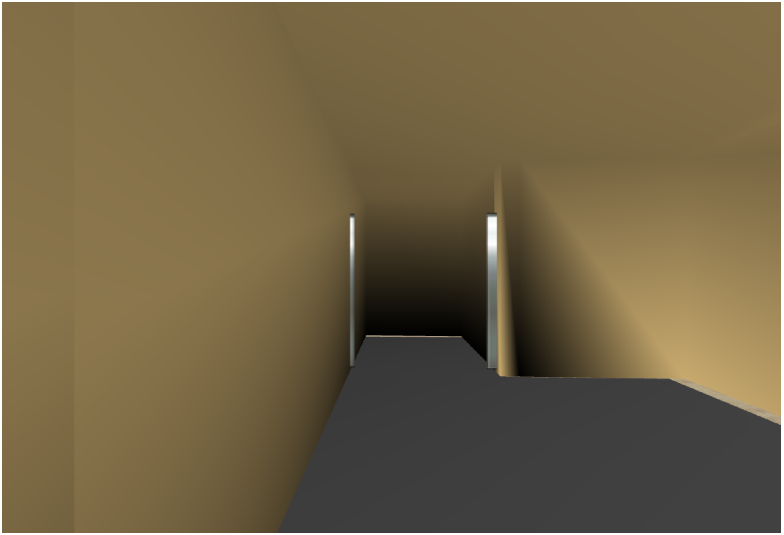

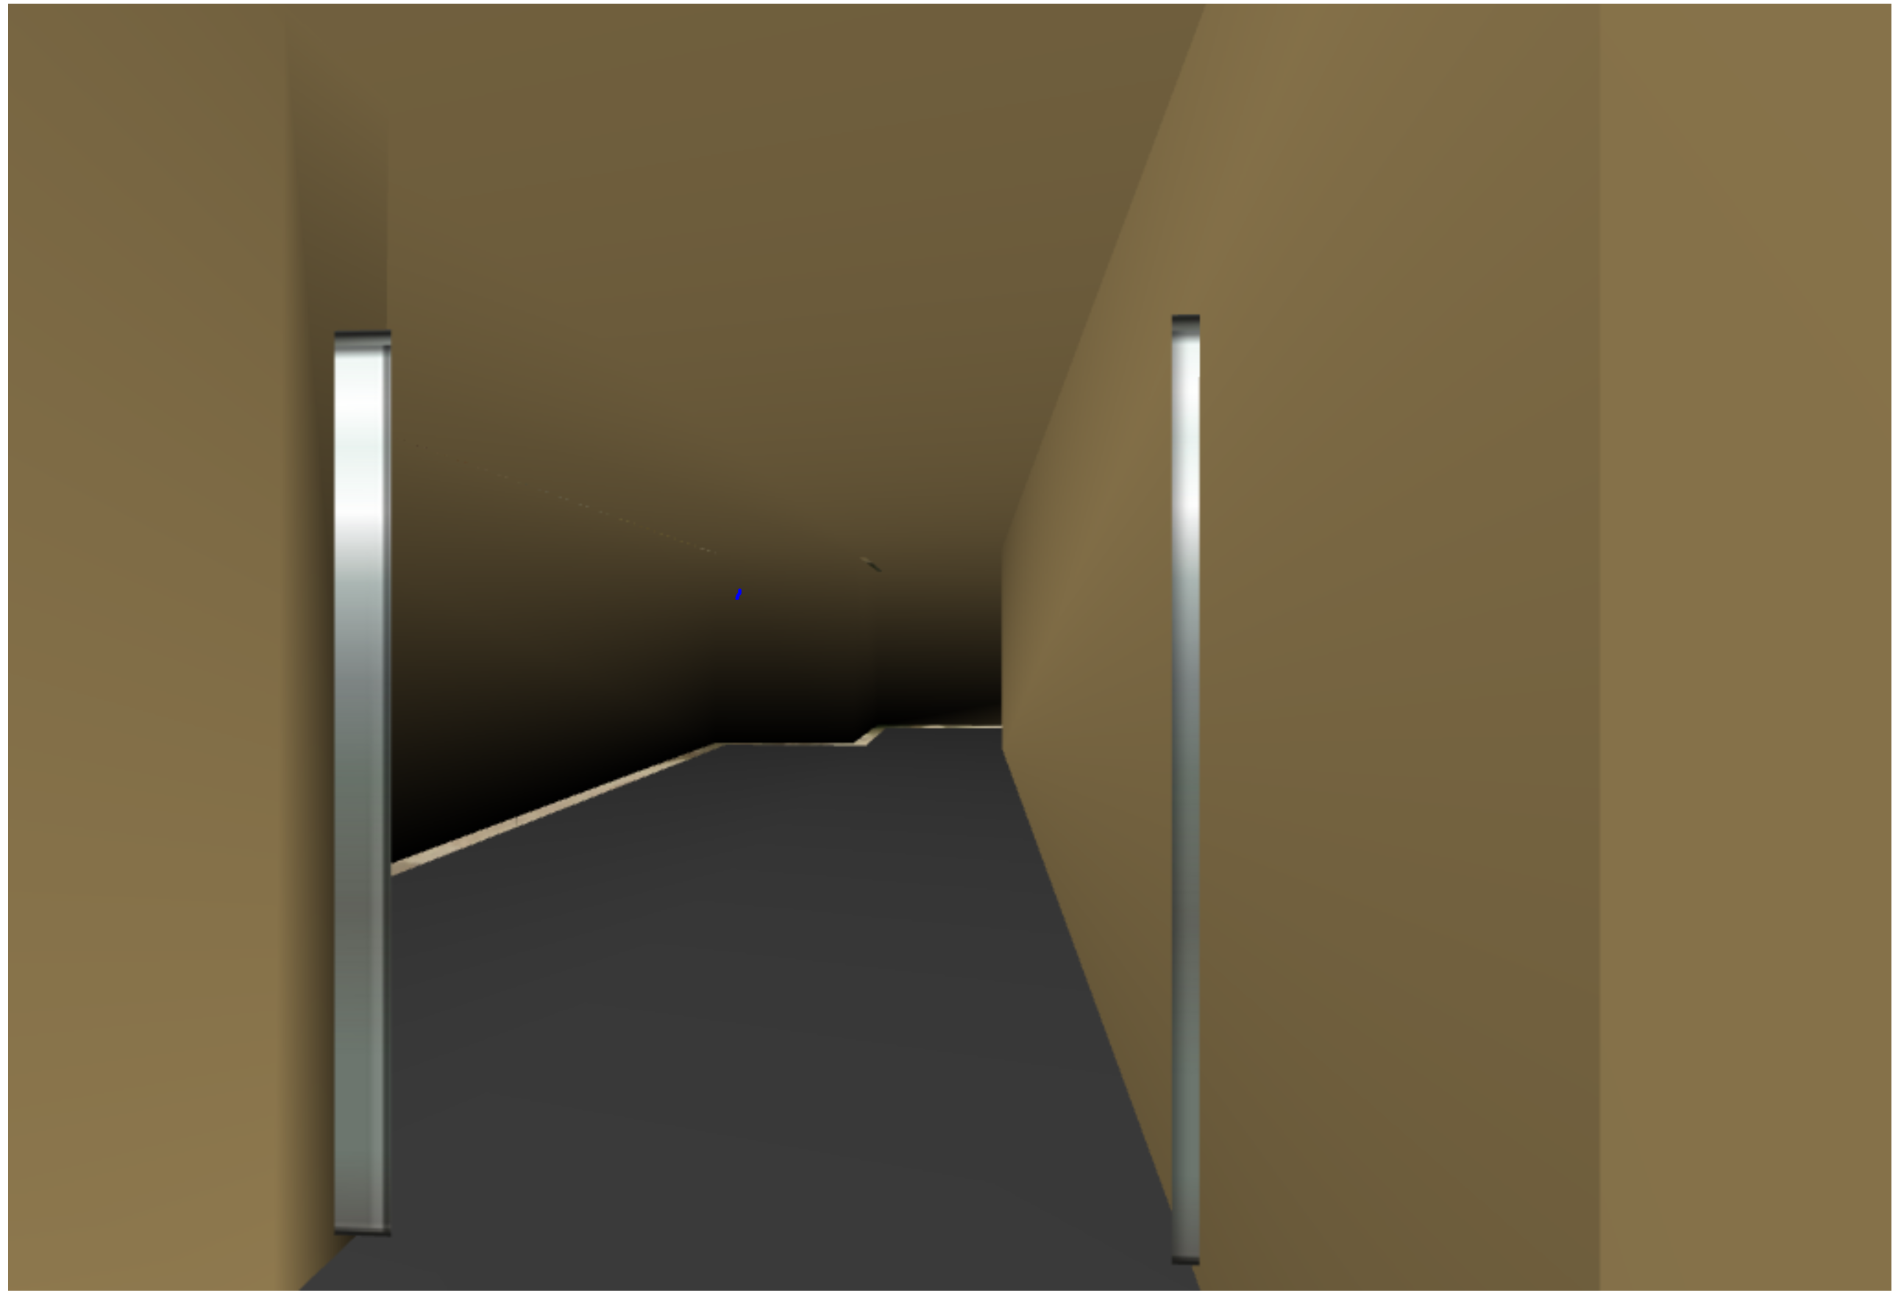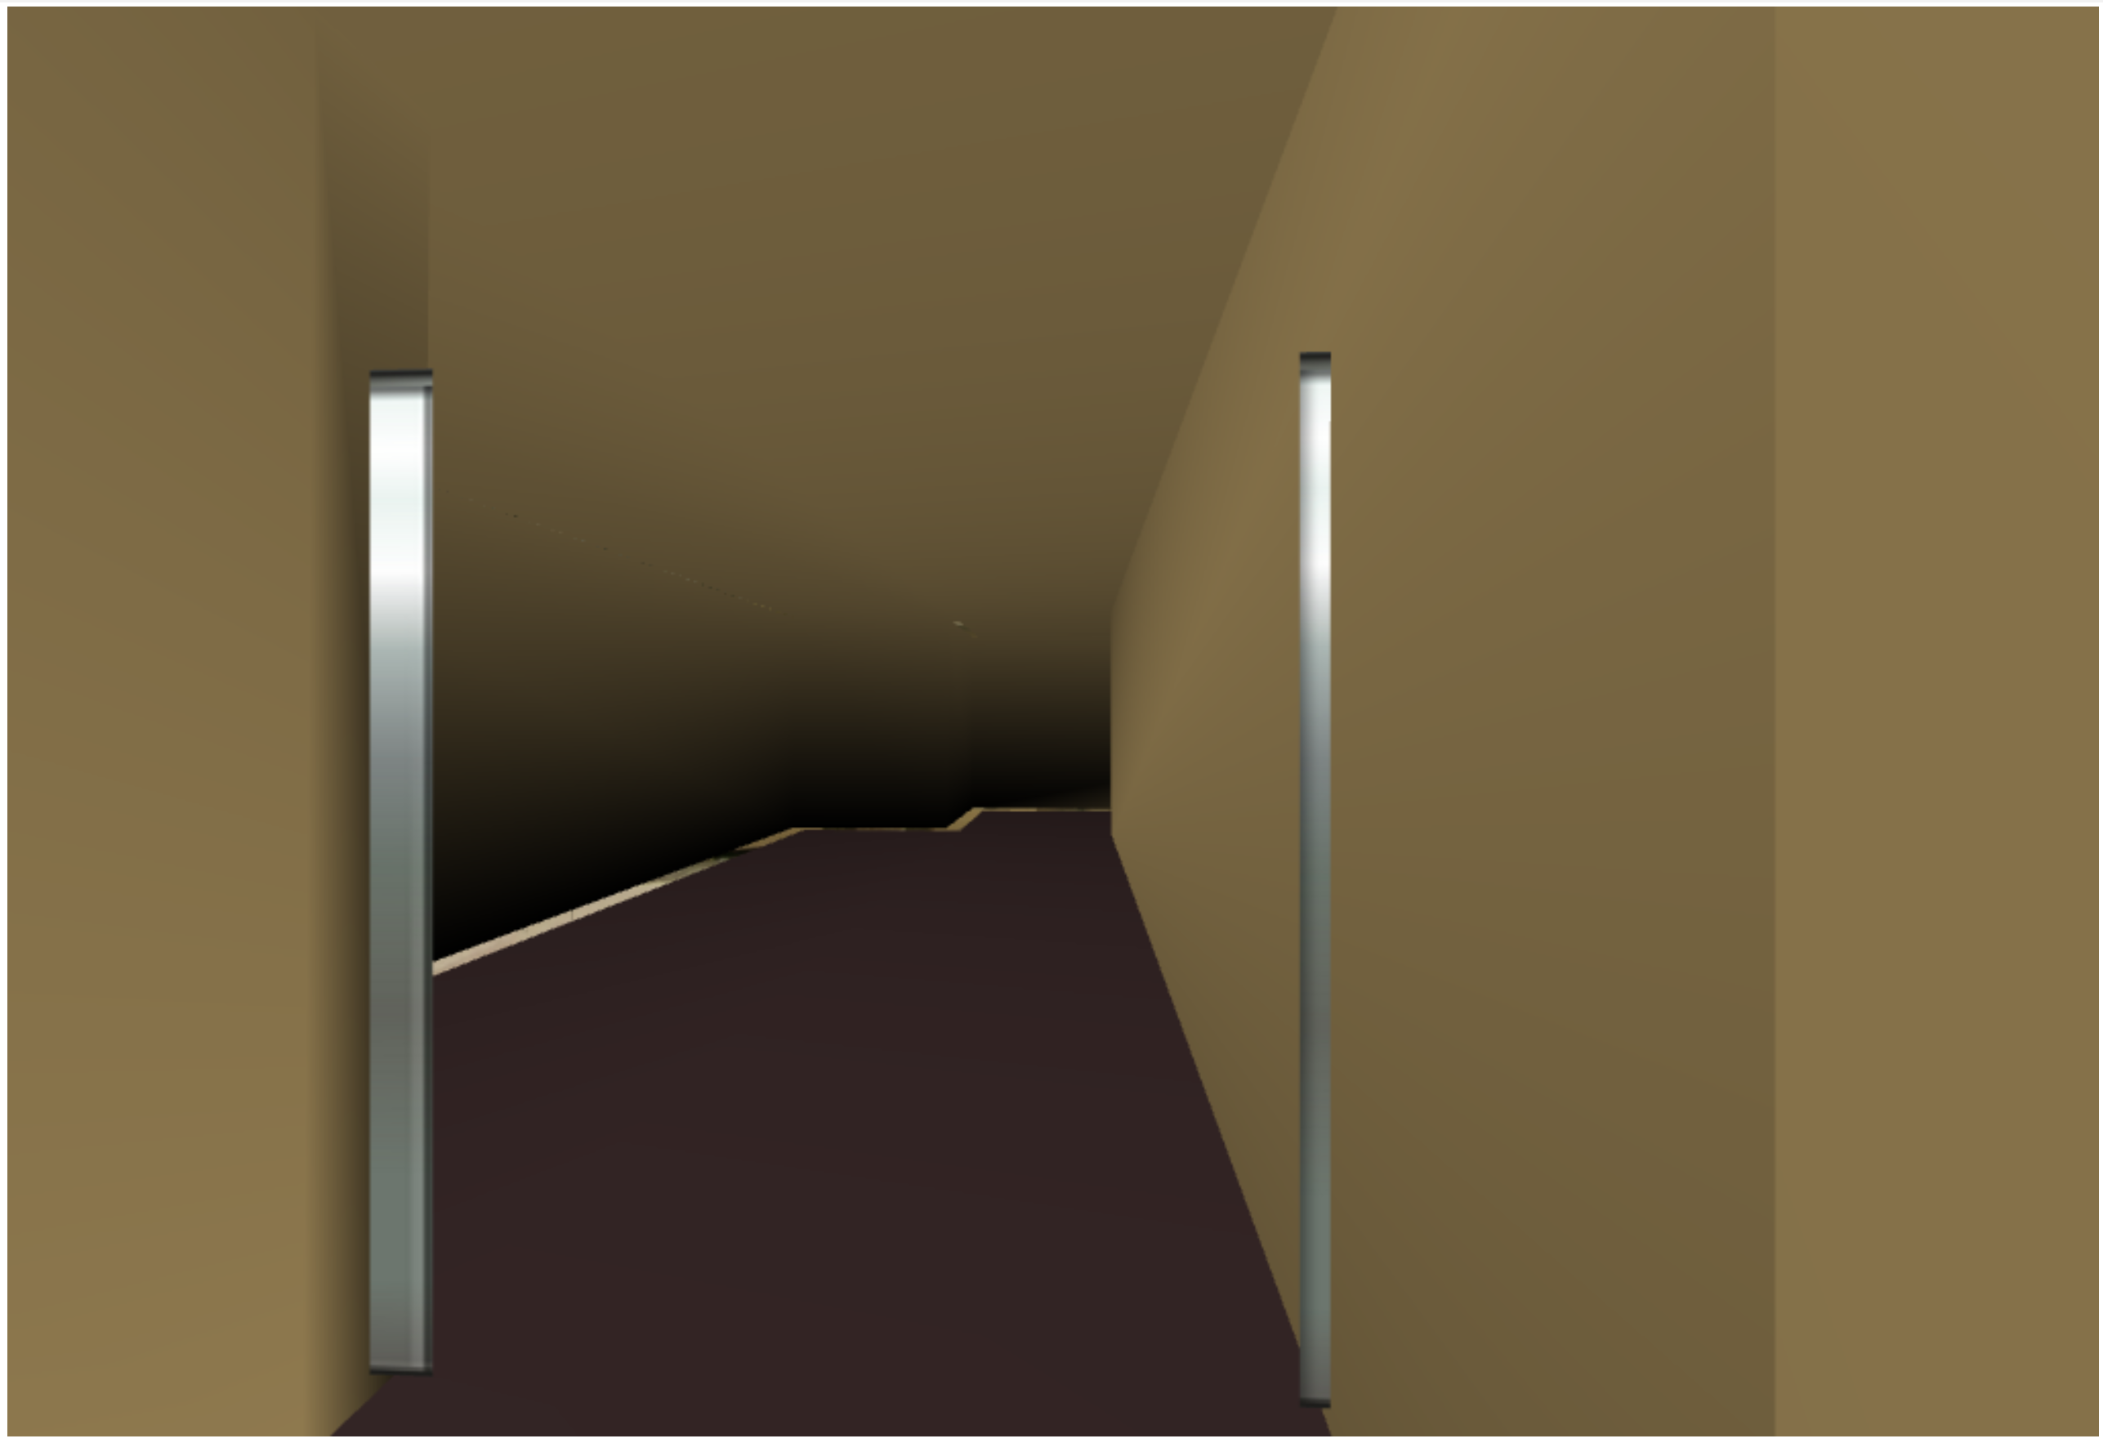

**Extra implantation.**

A cube map for fake surrounding is implemented. WebGL does not provide a cube map texture and it is implanted manually.



**Further implementation.**

**Collision detection.**

Currently user could walk through the walk, this could be prevented by implanting collision detection between user and environment.

**3D Models**

Currently the objects inside the building like vending machine are rendered as simple 2D billboards, those could be updated as 3D models for more realistic experience.